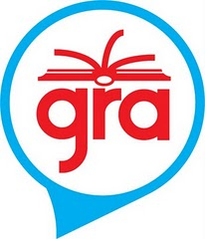
Hi families!

This year, our class will be participating in a project called the Global Read Aloud. This project will start October 5th and will run for approximately 6 weeks. The idea behind it is very simple; teachers around the world read the same book aloud to their students and then use technology to share the reading experience with these other classrooms. It is a free project and it fits perfectly into the standards we have to cover.

During the project, our class will be reading Fish by L.S. Matthews and connecting with students around the world who are reading the same book. We will use technology tools such as www.writeabout.com/ (please see attached info/permission page!) to facilitate these connections and conversations.

We are very excited to connect with others, especially since more than 400,000 students are already signed up to participate. This project will allow for our students to use technology tools in a meaningful way, as well as learn about other cultures, all while listening to a fantastic read aloud.

If you would like more information about the Global Read Aloud, feel free to visit the website www.theglobalreadaloud.com or I would be happy to answer any questions you may have. I look forward to starting this exciting project with your child, as well as seeing the connections we will make.

All my best,

Katie Cherry

